Que 1: What is data mining? What are its applications?
Ans: Data mining is a process of discovering useful knowledge from large data stores.
Or

It is a technique used for extraction of new and useful knowledge from large data store for decision making purposes.
Applications of data mining:
Business:
Modern business uses data mining to perform market analysis to identify new product bundles, finding the root cause of manufacturing problems, to prevent customer wearing away and acquire new customers, cross-sell to existing customers, to determine sales trends etc….
Data mining also contributes in customer relationship management Rather than randomly contacting a prospect or customer through a call center or sending mail, a company can concentrate its efforts on predicting customers who may be interested to use the offers.
Medicine, Science and engineering:
Many satellites gather huge amount of information on weather conditions. Data mining may be used to answer many question as volcano detection, earthquake detection, relation between ocean’s surface temperature and land temperature etc…
Data mining is also used in micro biology, for example it aims to find out how the changes in an individual's DNA sequence affects the risks of developing common diseases such as cancer, which is of great importance to improving methods of diagnosing, preventing, and treating these diseases.
Another example of data mining in science and engineering is found in educational research, where data mining has been used to study the factors leading students to choose to engage in behaviors which reduce their learning, and to understand factors influencing university student retention.
Data mining is used in many more applications like banking, traffic analysis, computer network analysis etc...

Que 2: Explain the process of knowledge discovery in databases (KDD).
Ans: KDD: The process of converting raw data into useful information is known as KDD. Data mining is a step knowledge discovery in databases.
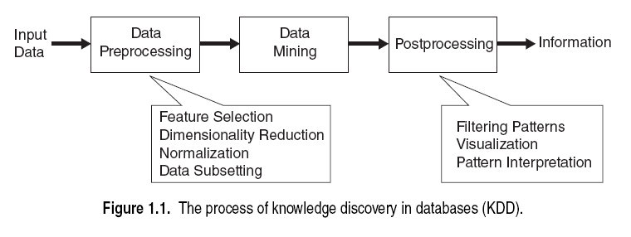
Input data: The input data may be flat file, spread sheet, relational tables etc...These data may be stored at a single place or distributed across networks.
Preprocessing: It is a process of converting the raw data into appropriate form suitable for data mining. Data preprocessing is the most time consuming step in KDD
Data processing may include following steps:
- Selecting data relevant to mining
- Data cleaning
- Missing values removal
- Incorrect or noisy data correction
- Remove duplicate data.(reduce redundancy)
- Data Transformation and integration and transformation
- Data reduction
Data mining: Various mining techniques like classification, clustering, association analysis are applied and data mining results (patterns) are generated.
Post processing: The various data mining results (patterns) are integrated and only useful results are filtered. Data post processing includes visualizing data mining results from different angles or view points. Some measures may be applied to remove false data mining results.

Que 3: What are the motivating challenges of data mining?
Ans: The following are the motivating challenges of the specific challenges that motivated the development of data mining.
- Scalability: “The amount of time required to extract the knowledge proportional to the amount of data”. Data mining algorithm need to handle huge amount of data. It is required that data mining should be scalable. Data mining algorithms use new data structures to handle different kinds of data. In some cases DM uses out of memory techniques to handle large data.

- High Dimensionality: Traditional data analysis techniques cannot handle high dimensional data. “Dimensions may be considered as attributes or properties of a data in some cases.” It is now common to deal with hundreds of attributes. Computational cost also increases with respect to the number of dimensions.

- Heterogeneous and complex data: Traditional method often deals with data of similar type. But complex data are often encountered in today’s world. For example, web pages contain semi-structured information. Climatic data contain time series data of various earth locations. Data mining should be able to deal with heterogeneous and complex data by considering relationship among data, such as parent child relationships etc...

- Data ownerships and distribution: Data is stored in different locations and owned by different people. Distributed data mining deals with following challenges.
- Reduction of communication cost to perform distributed mining.
- Consolidation of DM results from various sources.
- Security issues.

- Nontraditional analysis: In traditional statistics, a hypothesis was proposed and an experiment is designed to gather the data and then the data is analyzed with respect to hypothesis. But, in data mining many hypothesis are generated and data mining techniques are used to automate the process of hypothesis generation.

Que 4: Explain about the origin of data mining?

Data mining draws idea such as
- Sampling, estimation and hypothesis testing from statistics
- Search algorithms, modeling techniques and learning from Artificial intelligence, machine learning, pattern recognition.
- Data mining has adopted ideas from evolutionary computing, information theory, signal processing, visualization, information retrieval etc...
- DBMS to provide storage, query processing and indexing.
- Parallel computing to provide addressing massive size of data.
- Distributed computing is essential when data cannot be gathered in a single place.

Que 5: What are the two categories of data mining tasks?
Or
Explain data mining tasks.

Ans: There are two categories of data mining:
Predictive tasks: Predicting the value of an attribute based on values of another attribute is predictive task. The value to be predicted is known as target variable. And, the values used for making predictions are known as explanatory variables.
Descriptive tasks: It characterizes the general properties of a target class of data in database.

- Predictive modeling: Process of building a model for the target variable based on explanatory variable. There are 2 types of predictive modeling tasks 1) classification 2) Regression.
Classification: Classification is the process of finding a set of models which are used to predict the class of object whose class label is unknown. It is used for discreet target variables. Example: Predicting whether web user will buy a product online or not.
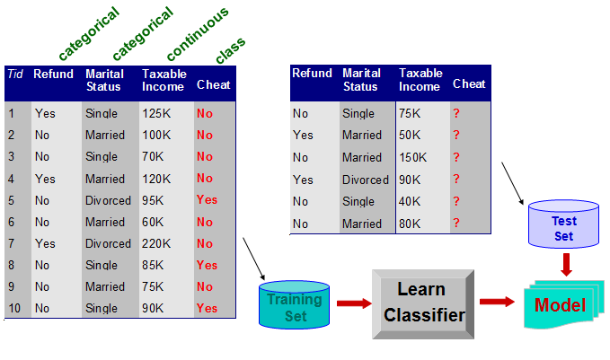
Regression: Regression is often used to predict the missing values rather than class labels. It is used for continues target variables. Example: Predicting the price of a gold or stock.
Example: Suppose, as sales manager of AllElectronics, you would like to classify a large set of items in the store, based on three kinds of responses to a sales campaign: good response, mild response, and no response. You would like to derive a model for each of these three classes based on the descriptive features of the items, such as price, brand, place made, type, and category. The resulting classification should maximally distinguish each class from the others, presenting an organized picture of the data set.

- Association analysis: It is used to discover strongly associated features in data. The discovered patterns are represented in the form of association rules. Applications of association analysis include, identifying web pages accessed together, identifying items bought together in a super market etc...
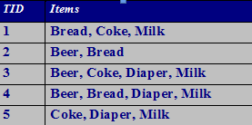
Example: Consider the supermarket billing database. Association analysis can be used to find the list of items bought together in a supermarket. For example coke and milk are bought together which is represented as (coke milk)
- Cluster analysis: It is a process of grouping data into classes or clusters so that objects within a cluster have high similarity in comparison to one another, but are very dissimilar to objects in other clusters.
Cluster analysis can be performed on AllElectronics customer data in order to identify homogeneous subpopulations of customers. These clusters may represent individual target groups for marketing. Figure shows a 2-D plot of customers with respect to customer locations in a city. Three clusters of data points are evident

- Anomaly detection: Detection of observations that are different from rest of the data is known as anomaly detection or outliers.

Example: Anomaly detection may uncover fraudulent usage of credit cards by detecting purchases of extremely large amounts for a given account number in comparison to regular charges incurred by the same account. Outlier values may also be detected with respect to the location and type of purchase, or the purchase frequency.

Que 6 What is meant by Data set, Attribute & Measurement scale and what is the relation between them.
Ans:
Data set: Collection of data objects can be viewed as data set. Other name for data objects are record, point, vector, event, case, sample, observation

Attribute: The characteristic of an object is known as attribute. In detail, Attribute is characteristics which describe an object that may vary from one object to another or from one time to another.

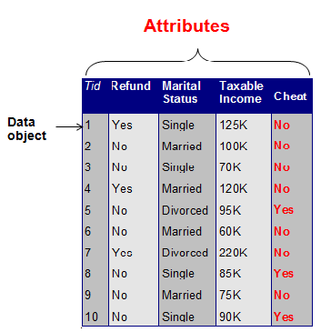
A Sample data set.

Measurement scale: It is a rule that associates a numeric or symbolic value with an attribute of an object.
For example, 1.consider an attribute weight, the measurement scale is kilos or pounds.
2. Consider attribute sex, we classify them as male or female.

Que 7: What are the different types of attributes?

Ans: 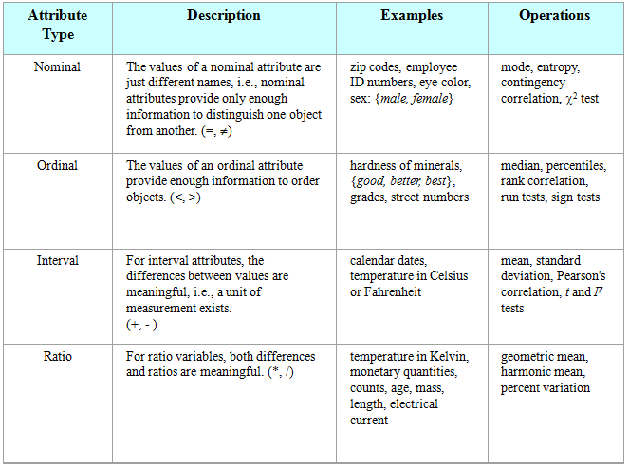

Attribute:
- Categorical or qualitataive
  - Nominal
  - Ordinal
- Quantitative or numeric
  - Interval
  - Ratio
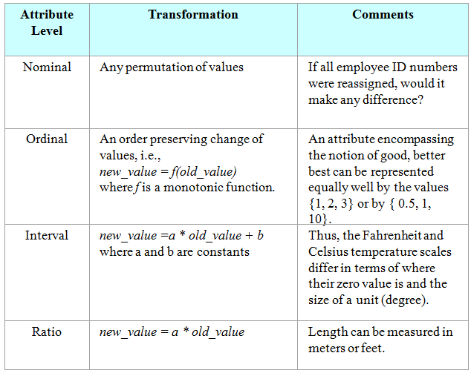

Que8: What is the difference between discrete and continuous attributes? What is meant by asymmetric attributes?
Ans:
Discrete Attributes | Continuous attributes
It has finite set of values | It has values real numbers
They may be represented as integer variables or symbolic variables | They may be represented as floating point variables.
Example: Pin code numbers, course of student, student register numbers. Grade of students | Examples: height of students, weight of students, marks of students etc...
Binary attribute are a special case in discrete attributes, in which we have only 2 values, Example: /female, yes/no, true/false etc.. | ------------

Asymmetric attributes: For asymmetric attributes only the presents of a value is given important.
Consider a table:
Reg no | Name | Cloud computing | Android Apps Development | Java | .Net
10PA1A0567 | T.Ramesh | 0 | 2 | 1 | 0
10PA1A0589 | O.Harish | 3 | 1 | 0 | 0
Consider the above table which represents the books issued by students. Asymmetric attributes considers does not consider zero values.

Binary asymmetric attributes:
Reg no | Name | Cloud computing | Apps Development | Java | .Net
10PA1A0567 | T.Ramesh | 1 | 0 | 0 | 0
10PA1A0589 | O.Harish | 0 | 1 | 0 | 0
Consider the above data, 1 considers the student took the course and 0 represents student didn’t took the course. Binary asymmetric attribute considers only presents of a value.

Que 9: What are the three general characteristics of data sets?
Ans:
Dimensionality: It refers to the numbers of attributes in a dataset. Data set with very less number of dimensions is easy to analyze than data set with more dimensions. Dimensionality reduction technique may be used to remove unnecessary dimensions.
For Example: Consider student marks analysis containing attributes (Reg no, name, father’s name, marks date of birth etc...), Fathers name and date of birth plays no role to analyze a student marks and may be removed.

Sparsity(Not Dense): Some data sets may contain many zero value and very less non zero values. The non zero values may be considered to save analyzing time & storage space. Many Data mining algorithm works well with less or sparse data

Resolution (level of abstraction): Data may be obtained at different levels of resolution. The properties are different at different levels of abstraction.

Consider the above example: student id and student name are important attributes at student level, class strength, faculty are important at class level, Dept name, subjects are important at dept level, college code, admissions, placements are important at college level.

Que: Explain different types of data sets.
Ans:
:

Record data:
Record data is a collection of records each of which consists of a fixed set of attributes. Record data is usually stored in flat files or relational databases.
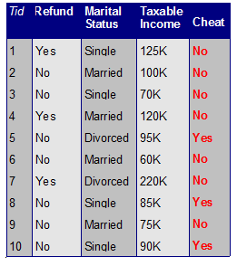
- Transaction data: A special type of record data, where each record transaction) involves a set of items. For example, consider a grocery store. The set of items purchased by a customer during one shopping trip constitute a transaction. This type of data is known as market basket analysis.

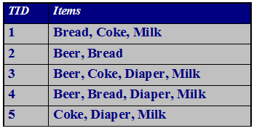
- Data matrix: If data objects have the same fixed set of numeric attributes, then the data objects can be thought of as points in a multi-dimensional space. Such data set can be represented by an m by n matrix, where there are m rows, and n columns, one for each attribute. This type of matrix is known as data matrix. Standard matrix operation may be applied on it.
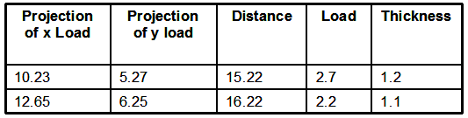

- Sparse data matrix: It’s a special case of data matrix where only non zero values are important. Consider the below example where each document is represented as term vector. And term is attributes. In document 1 ,word (team) is found 3 times, Word(play) is found 5 times and so on.
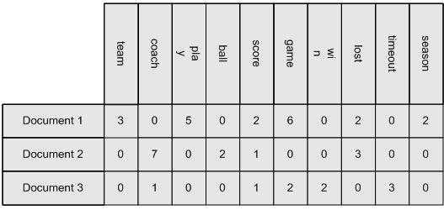

Graph based data:
- Data with relationships among data objects: Graphs are used to represent relationship between data objects. The data object can be considered as node and relationship between the nodes can be represented by links. Consider an example of WWW where web pages are interlinked with other pages. Links provide good information to search and extract relevant WebPages.
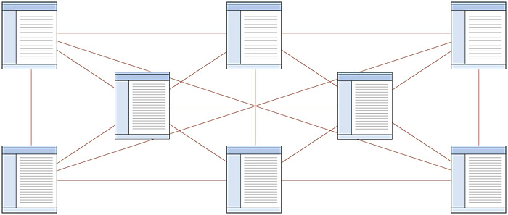

- Data with objects that are graphs. If objects contain subobjects that have relationship among them, then objects are represented by graphs. For example consider water molecule(object) which can be represented as:
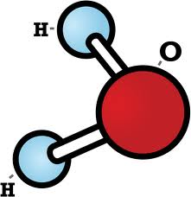
Ordered data

When attributes have relationships in terms of time or space, then that data is known as ordered data.

Sequential data (temporal data): It is an extension of record data with time associated with each record.

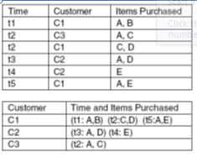
Consider the customers data maintained by an online store. We can find some interesting patterns from the above data, For example: customers who bought a mobile phone are more likely to buy mobile case,& screen guard in near future

Sequence data: It is a data set which contains a sequence of actions, such as sequence of words or letters. For Example: The DNA sequence of two people may be analyzed to know the relationship between them. Below is the human genetic code using four nucleotides.
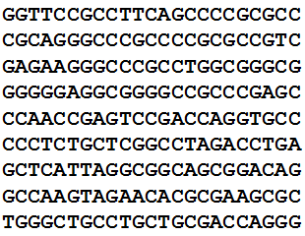

Time series data: It is used to store sequence of data that changes over time. For example the value of stock of a company which changes with respect to time

Spatial data: It contains spatial related information like geographic maps data, VLSI chip design data, Medical and satellite image data etc…Its main application is in weather data. For example climate of mountain areas located at various altitude. An important aspect of spatial data is spatial auto correlation; that is two points on earth that are close to each other usually have similar temperature and rainfall.

Que: Explain data quality? What are the various aspects of data quality related to data measurement and collection?
Ans: Quality of data plays an important role in data mining. We can get quality knowledge from a good quality data. The quality of data is not perfect due to following reasons:
Human errors during data entry
Hardware limitations
Flaws in data collection process
Values or entire object may be missing
There may be duplicate objects.
Inconsistency
Etc…
Definitions:
Error: For continuous attribute, the numerical difference of measured and true value is called error.
Measurement Errors: It refers to any problem resulting from the measurement process.
Data collection error: It refers to errors such as omitting data objects or attribute values.
VARIOUS ASPECTS OF DATA QUALITY RELATED TO DATA MEASUREMENT AND COLLECTION:

Noise and artifacts:
Noise is a random error or variance in a measured variable. It may involve the distortion of a value or the addition of false object. Noise is generally associated with temporal and time series data. Image processing techniques are used to reduced the noise (Removing noise is difficult). Data mining algorithms should be robust (tolerate noise) to deal with noise.

Artifacts: Deterministic distortion of data is often referred as artifacts.
Or
A substance or structure not naturally present in the data being observed but formed by artificial means. For example: a mark on a set of photographs.

Precision, Bias and accuracy:

Precision: The closeness of repeated measurements (of the same quantity) to one another. The precision is generally measured by standard deviation

Bias: A systematic variation of measurements from quantity being measured. The bias is generally measured by mean.

Accuracy: The closeness of measurements to the true value of the quantity being measured.

Significant digit: The Nearest acceptable precision value of the digit is known as significant digit.+_ 0.05.

Outliers: A data set may contain data objects that do not comply with the general behavior or model of the data. This data objects are outliers. Most data mining algorithm methods discard outliers as noise or exceptions. However, in some applications such as fraud detection, the rare event is more important.

Missing values

Missing values are often encountered in data sets. This may due to incomplete information collection.
Missing values are handled in the following ways:
Eliminate data objects or attributes: This method is not very effective, unless the tuple contains several attributes with missing values. A Related strategy is to eliminate attributes that have missing values.
Estimate missing values: In some cases the missing values can be estimated my using the other values. For continuous attributes, missing values can be estimated by using the average of the remaining values. For categorical attribute, missing value can also be estimated using the most common values.

Ignore missing values during analysis: Data mining algorithms should be robust and be able to deal with missing values. In large data sets having some missing values may not affect data mining results.

Inconsistent values (conflicting):
There may be inconsistencies in the data recorded for some transaction. For example: while entering some personal data the pin code may not match with name of the city. Height of a person may be negative. Height of person does not match with his weight. This type of inconsistency may be reduced by using some checks. But removing inconsistency may need heavy data instead.
Duplicate data:
There may be many duplicate values in a data. There are two main issues. First, same data object may be represented by two different objects ( different e-mail address for same person).Second, accidentally combining two different objects.(2 people may have same name).The term duplication is often used to refer to the process of dealing with this issues.

